ATTACHMENTS

Milestone 1: Create UI Policy on Incident

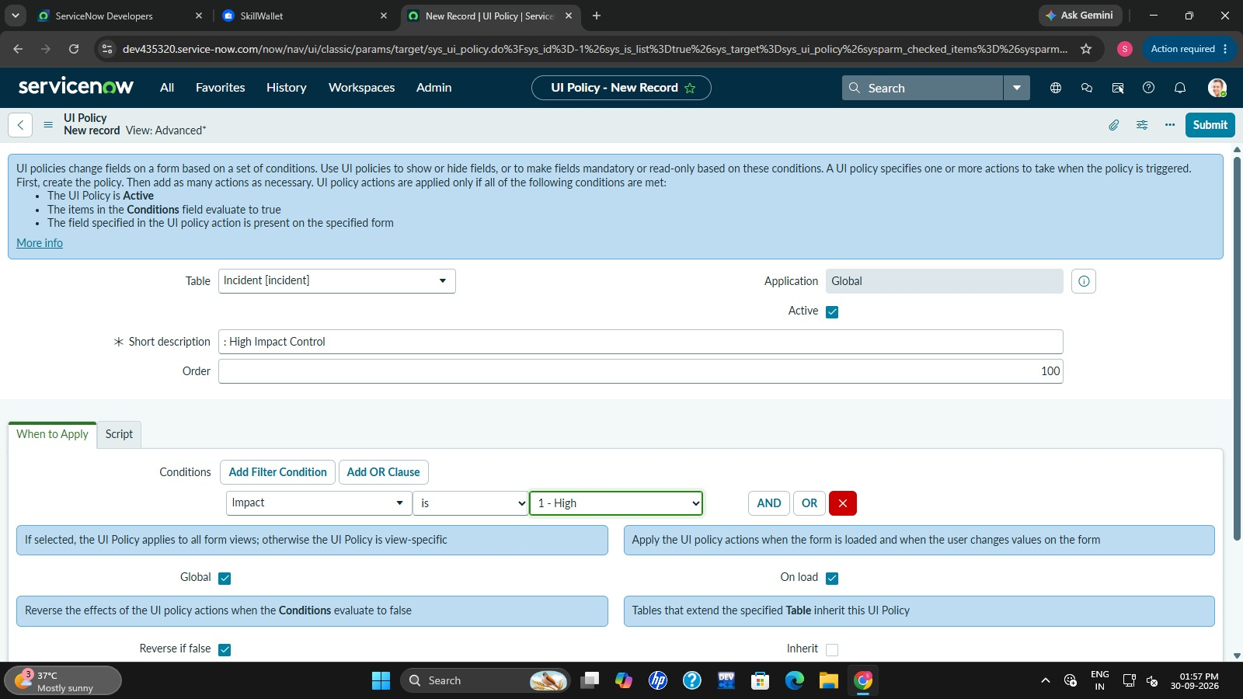

Milestone 2: Create UI Policy Action – Urgency

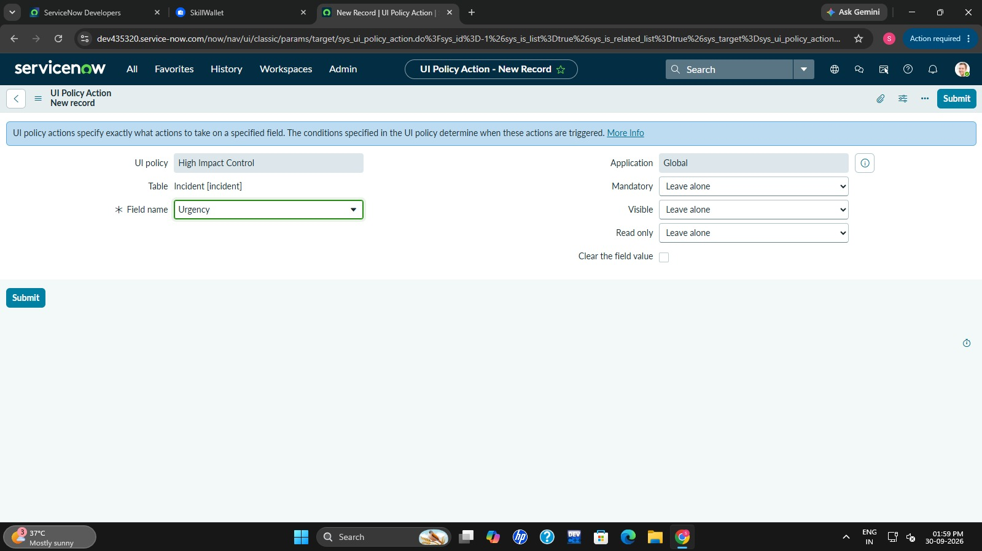

Milestone 3: Create onChange Client Script

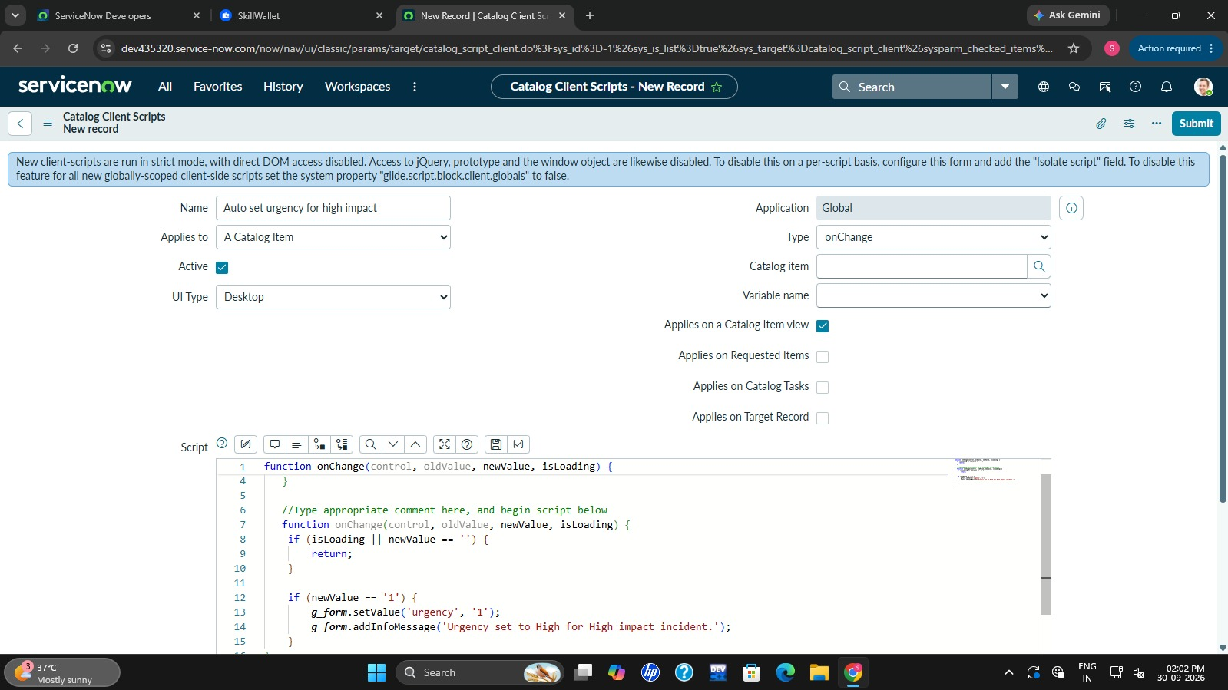

Milestone 4: Create onSubmit Client Script (Save Validation)

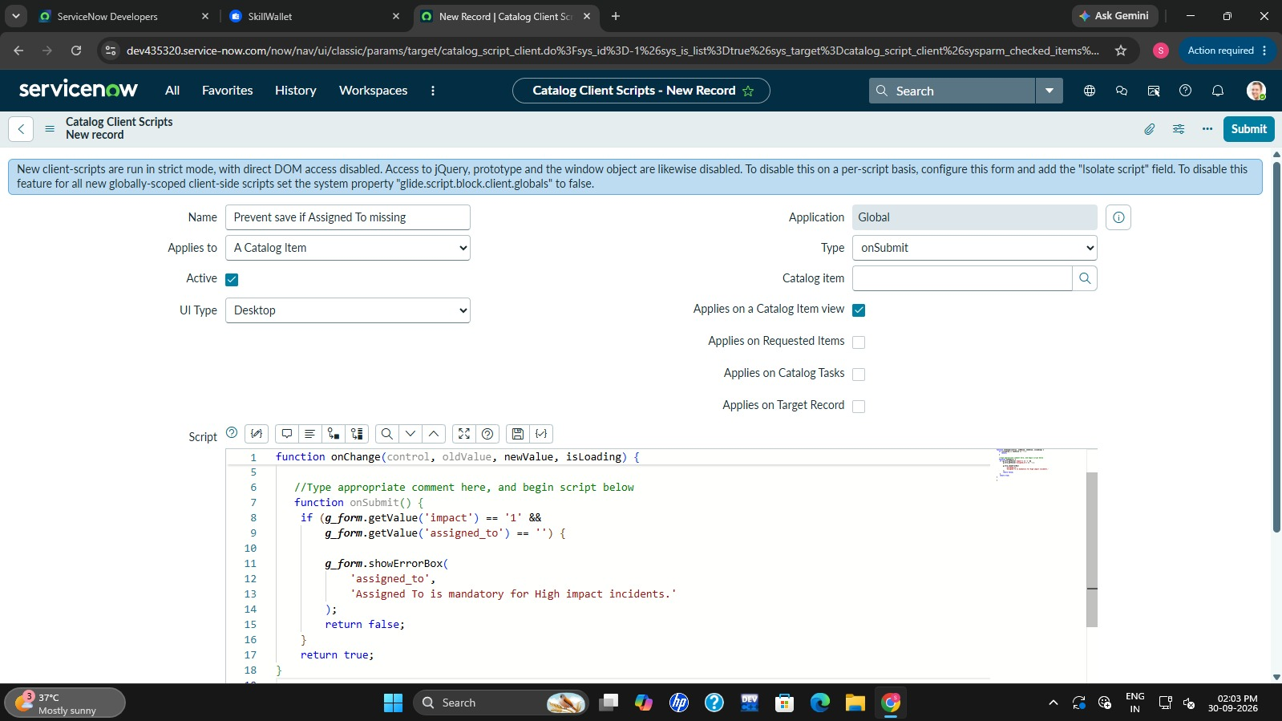

Milestone 5: Create onCellEdit Client Script
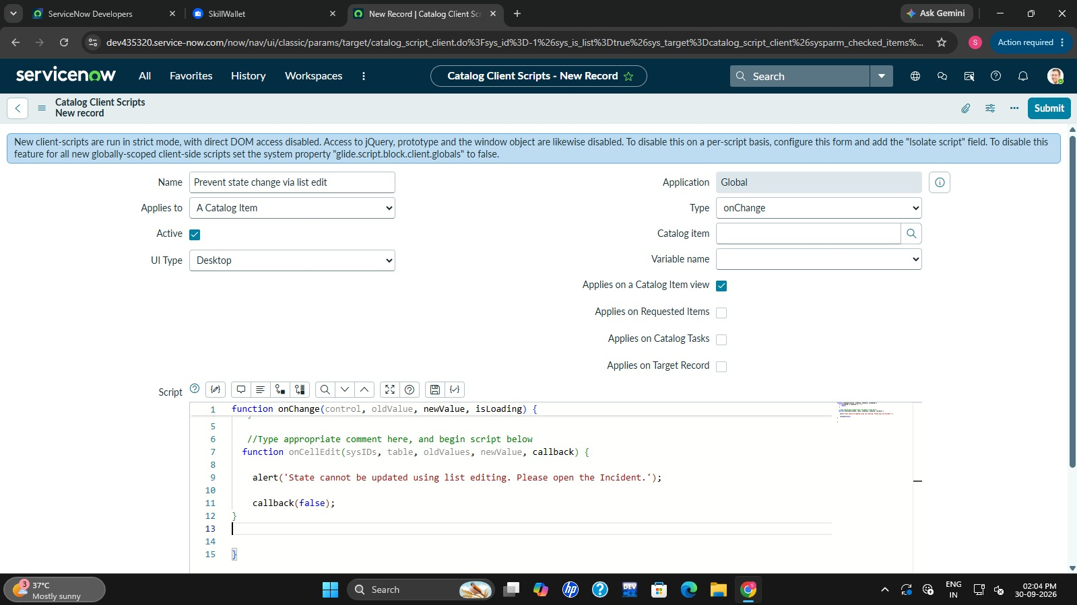
Milestone 6: Testing the Configuration
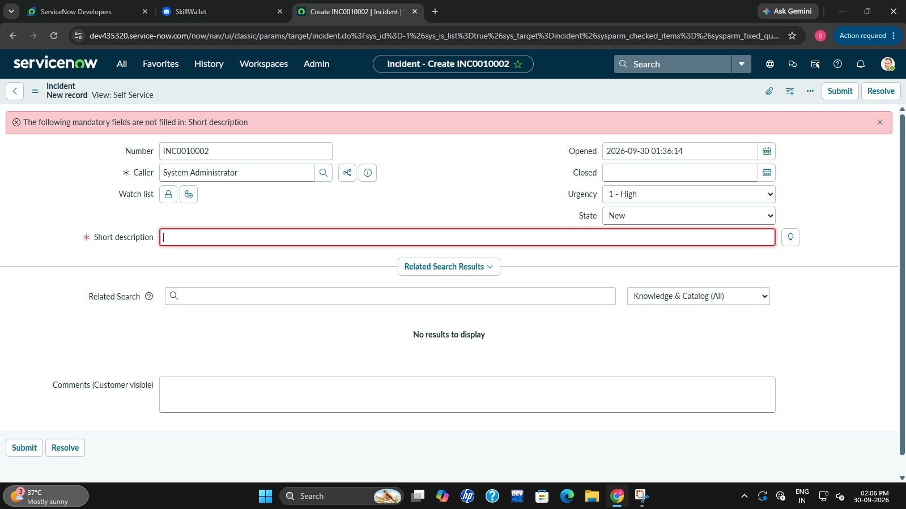

Conclusion
